Web Mining Lab Assignment

Name: Om Ashish Mishra

Registration Number: 16BCE0789

Slot: F2

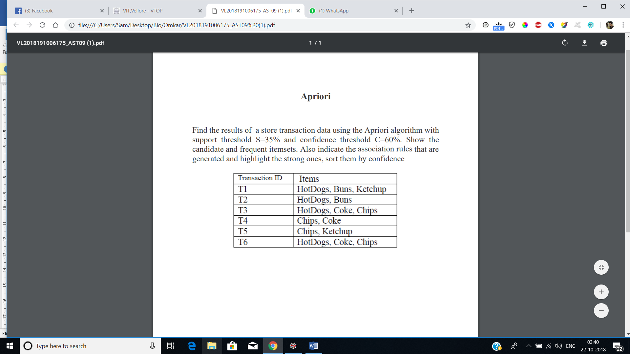

**Code:**

import numpy as np

import matplotlib.pyplot as plt

import pandas as pd

from apyori import apriori

dataset = [['HotDogs','Buns','Ketchup'],['HotDogs','Buns'],['HotDogs','Coke','Chips'],['Chips','Coke'],['Chips','Ketchup'],['HotDogs','Coke','Chips']]

print("Given Dataset:")

print('--------------------------')

for i in dataset:

for j in i:

print(j + ' | ', end="")

print('\n--------------------------')

ar = apriori(dataset, min_support=0.35, min_confidence=0.6, min_lift=1, max_length=3)

result = list(ar)

lofr = len(result)

finalres=[]

for i in result:

for j in i[2]:

finalres.append([j,i[1]])

finalres.reverse()

print("\n\n")

for i in finalres:

p = i[0]

item=[ x for x in p]

if(len(item[0])>0):

x1, *_ = item[0]

else:

x1="Null"

if(len(item[1])>0):

x2, *_ = item[1]

else:

x2="Null"

print('\n\n--------------------------------')

print("Association rule: " + x1 + " -> " + x2 )

print("Confidence: " + str(i[0][2]))

print("Support: " + str(i[1]))

print("Lift: " + str(i[0][3]))

print('--------------------------------')

print()

**Code Screenshots:**

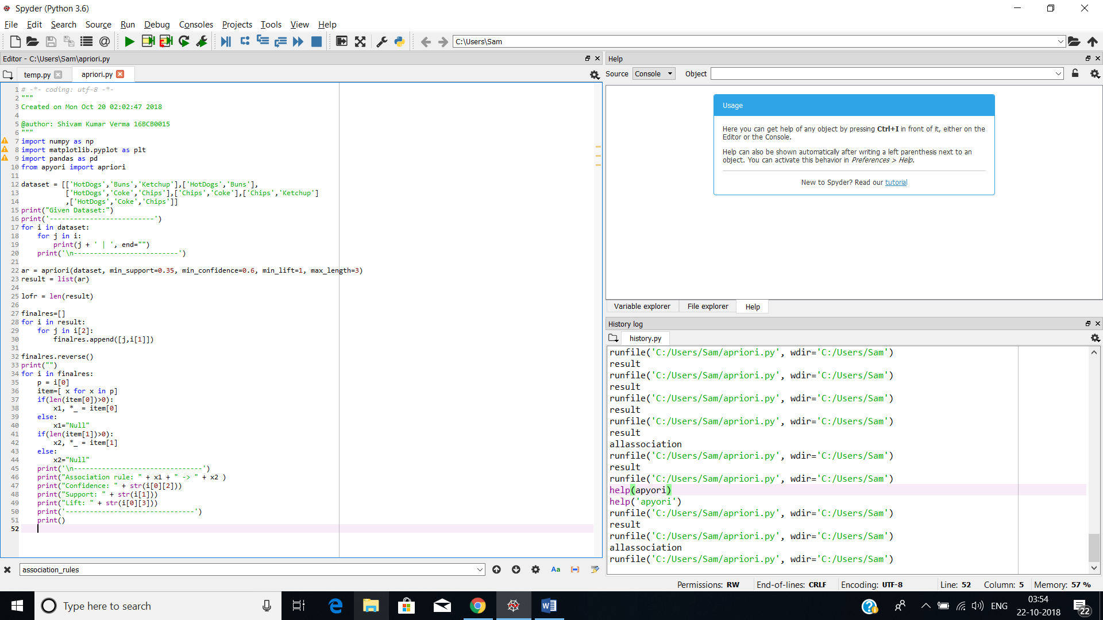

**Output:**

